Local Partnerships

Report on Performance and Use of RSG

2014 – 2015

Contents

- Introduction………………………………………………………………… 2
- Our financial performance……………………………………………….. 2
- Maintaining the quality of our work and client feedback……................ 3
- Adapting to changing priorities………………………………………….. 3
- Revenue Support Grant………………………………………………….. 4
- Looking forward to 2015-16 RSG Activity………………………………. 6
Appendix 1 Use of RSG in 2014-15……………………………………… 8
Appendix 2 Case Studies from 2014-15………………………………… 11

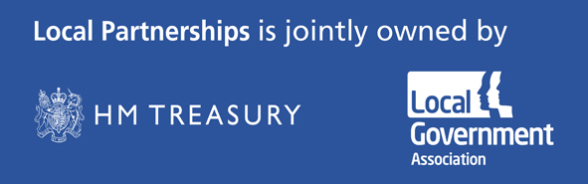

Introduction

Local Partnerships is jointly owned by the LGA and the Treasury and was set up to help the public sector deliver at the local level. We support central and local government, health and other local bodies ensure their key priorities are delivered and clients secure value for money.

In 2014/15 Local Partnerships received a top-slice of £1.7 million from the LGA’s RSG allocation. This has reduced to £1.5 million for 2015-16.

Local Partnerships set out four main objectives in its Business Plan for 2014-2015:

- To ensure in our activities and services we meet the priorities of our owners, and their financial expectations of the organisation;

- To continue to build new market offers in each of the six programme areas, which meet market needs and are sustainable beyond the next general election;

- To ensure LP continues to deliver programmes and projects to the highest possible standards

- To continue to raise LP’s profile with stakeholders and clients
Our performance in meeting these objectives and our assessment of likely business activity for the year ahead, now the general election is over, gives us confidence we will continue to maintain and grow a sustainable organisation that can serve local government and other clients well.

Our financial performance

The Board agreed an ambitious Business Plan for 2014-15, aiming for turnover of £10.36 million and a surplus of £541,000. Fig 1 below, shows we performed well against these targets and in particular achieved a surplus twice that we had estimated.

Fig 1 – Financial performance 2014-15

Revenue Category | 2014/15 | 2014/15 | 2013/14
 | Budget | Actual | Actual
 | £'000 | £'000 | £'000
RSG | 1,700 | 1,700 | 1,900
External Income | 8,664 | 8,530 | 7,726
Total Income | 10,364 | 10,230 | 9,626
Total Costs | (9,823) | (9,037) | (7,950)
Net Surplus | 541 | 1,193 | 1,676

In line with the policy of the LGA and HMT, half of the surplus was distributed to the owners on 5 August 2015, comprising the repayment of loan stock of £300,000 to each owner.

Maintaining the Quality of our Work and Client Feedback

The quality of our work and resulting customer advocacy remains our most powerful marketing tool. During the course of the year we repeated our formal client survey. In addition the LGA included a question on Local Partnerships in its annual survey of local authorities. The feedback we received from both surveys was encouraging.
The LP client survey was sent to 173 clients, most of which were local authorities. Of these 70 responded. Of the 70:
- 62 said LP had exceeded or fully met their expectations

- 65 said LP employees were excellent or good (34 saying excellent)

- 66 said they would use LP again

- 67 said they would recommend LP to others (2 said maybe and 1 said it was too early to judge)

- Of 29 clients who had paid directly for their assignment (the others being funded by a central government department, for example), 23 said Local Partnerships provided excellent or good value for money (the other 6 said VfM was satisfactory).

In terms of the LGA’s own survey of local authorities, nearly three fifths of the respondents (58%) had heard of Local Partnerships, a significant increase from 2013 (47%). By role, officers are more likely to have heard of Local Partnerships than frontbench councillors and backbencher councillors (66%, compared with 54% and 57% respectively). By role type, awareness is significantly higher amongst chief executives (90%, a significant increase from
67% in 2013) than amongst other roles (58% overall).
The LGA survey demonstrated that of those that have used services provided by Local Partnerships, 71% are satisfied with them. This includes 14% that are very satisfied. Just 5% of those that have used the services are dissatisfied with them. There are no significant differences in satisfaction with the services provided by Local Partnerships by region or role.

Adapting to Changing Priorities

Fig 2. shows the changing balance of activities over the period 2013-2016.
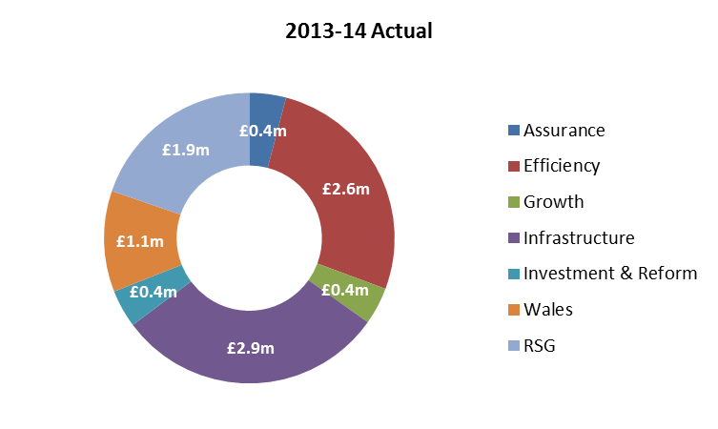

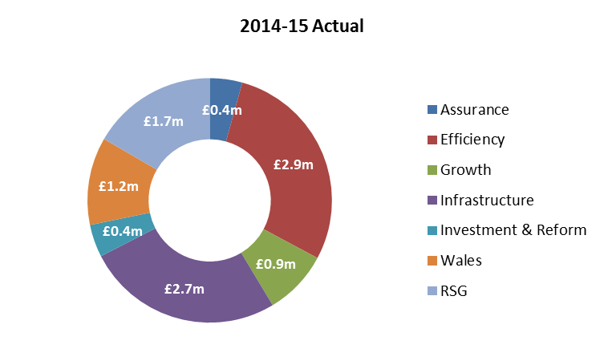

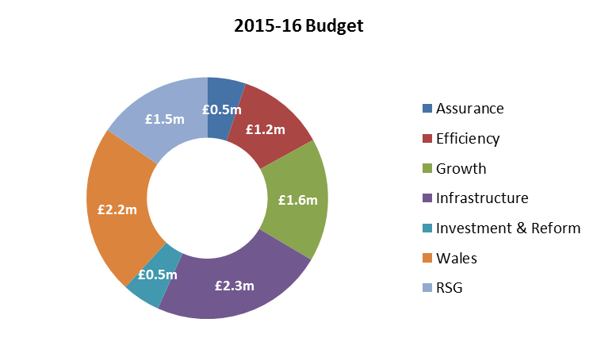

The pattern of the last three years shows a clear reduction in the dominance of infrastructure work (predominantly waste infrastructure) and an increasing amount of work related to economic growth, including housing and regeneration, as well as an increase in the amount of work done in Wales, both of which are helping to compensate for the gradual reduction in RSG.

Revenue Support Grant

Local Partnerships receives a proportion of Revenue Support Grant (RSG) from the LGA to provide direct benefit to councils, and develop new resources for local government to improve services and save money.

In 2013-14 we received an allocation of £1.9 million of RSG which dropped to £1.7 million in 2014-15 (and £1.5 million in 2015-16).

Our use of RSG in 2014-15 has provided direct benefit to our owners, to councils and, through new service offers, will continue to equip Local Partnerships to remain agile in future years.

We are very pleased we are collaborating to an increasing extent with the LGA. Examples of this are our joint work on the development of shared management arrangements with two Somerset councils, a transformation programme with a Devon Council and the work to support a wide range of bids for Transformation Challenge Award funding.

In 2014-15 we focused on three broad areas:

- efficiency initiatives to enable local authorities to make savings to meet their budget challenges

- dissemination of best practice to the sector as a whole

- piloting new services and programmes to add value to the sector and form a platform for future developments

We invested our RSG allocation in activities that accorded with the principles agreed by the Board and the LGA, and which were predominantly free at the point of delivery to local authorities.

Investing in the public sector

RSG funding is an investment by the public sector, in the public sector, and as with all our endeavours, we keep our owners’ priorities at the forefront of all our activities. Under this category highlights of our work funded from RSG include:

  - Efficiency - the establishment of a PFI Help-Desk to enable public sector bodies make savings from PFI contracts at no cost; and work with councils to review their efficiency savings programmes more broadly;
  - The RE:FIT programme, enabling councils to make savings in energy consumption;.

  - Public service reform - our work with Nottingham on combined authority design; advice and support to councils in relation to their Transformation Challenge Award programmes; and our continued support to spin-out networks;

    - Growth - work with local authority delivery partners and LEPs, and on how the public sector estate can be used to support economic growth while making financial savings;
    - and our work with councils to accelerate the delivery of housing growth.

Dissemination of best practice

One of our core operating principles is the dissemination of best practice to the sector as a whole. We do not seek to hoard our intellectual capital but to share it freely. We have demonstrated this principle across our work, and set out a few examples below:

  - The publication on our web-site of practical case studies drawn from every area of our activity;

  - the production of a report highlighting the potential for savings via collaboration in design, management and delivery of highways maintenance projects’

  - the publication of the Rebuilding our Economies report, highlighting what councils in the West Midlands region are doing to sustain growth in their local economies;
  - the publication of the Efficiency report for Yorkshire and Humberside disseminating best practice in the region in relation to waste collection and joint working.

Piloting new services and programmes

With an eye to the future, we have piloted new services and programmes. The primary objective has been to develop services that will add value to the sector and form a platform for the changing environment. Under this category, highlights include:

  - the piloting of a new assurance review offer to local authority trading companies;

  - our work with local government and the Environment Agency to improve their mutual engagement in delivery of flood protection projects;

  - our initial work to develop regional consortia to oversee contract management;

  - our research programme into councils’ strategic commissioning

A fuller analysis of our RSG funded activities is shown in Appendix 1 and Appendix 2 sets out some sample case studies.

6 Looking Forward to 2015-16 RSG Activity

Local Partnerships’ allocation of RSG for 2015-16 has dropped to £1.5m. This section sets out our agreed areas of activity in 2015-16 following discussions with the LGA, in line with our strategic partnering agreement. That agreement:

  - identifies potential areas of collaboration to ensure dovetailing of our activities for the benefit of the sector

  - ensures, through regular formal and informal contact at officer level, our activities are targeted for optimal benefit.

Our areas of activity will include:

- as part of the feasibility study into broadening the potential for commercial collaboration with the LGA we will be undertaking savings and efficiency reviews for 3 councils that will include an analysis of their adult care service, and health and social care integration

- a joint LGA/ Local Partnerships assurance review of progress on Council programmes funded from the DCLG Transformation Fund, and a series of network events to share learning from the reviews

  - a feasibility study into website enhancements to provide a broad-ranging virtual help-desk, offering connections to networks and communities of practice across a range of services including efficiency, Public Service Reform and management of major programmes/ projects;

  - early work on training events for Councils on contract management, project and programme management, where we can draw on our existing expertise and where we have direct market evidence of need and interest;

  - continued funding of the RE:FIT programme to comply with DECC’s match-funding grant requirement;

  - a continuation of our contract management collaboration work with the aim of establishing a consortia of Councils to take a regional approach to contract management;

  - work with councils - nominated by the LGA Regional Principal Advisors - to support them on their public service reform initiatives, including the creation of LATCOs;

  - continued expert legal support to the LGA on procurement issues;

  - assistance to emerging combined authorities and other council groupings;

  - development of a new digital exploitation assurance review;

  - a feasibility study on whether there is a commercial rationale for Councils investing in a private rented sector portfolio; and

  - continued support to regional joint waste working partnerships.

The Revenue Support Grant funding provided by the LGA to Local Partnerships continues to provide substantial and tangible benefits to local government in terms of savings and increased effectiveness. It is vital this funding continues through the next five years.

Appendix 1

Analysis of LP RSG funded activities 2014-15

Activity Description |  |  |  | Benefits
 |  |  |  | No. of councils | Dissemination |  |  | LGA  priorities
Development of new assurance review offers  Highways maintenance efficiency programme  Lessons learned  Internal Assurance Toolkit | - council-wide transformation  - Local authority trading companies  - support for action-planning and implementation.  - Lessons learned from reviews of business change projects  - Further development of toolkit based on early adopter feedback |  |  | 8  10  c100  5 | ✓ |  |  | ✓
Contract efficiency review (highways) | - the contract to meet current needs |  |  | 1 | ✓ |  |  | ✓
Contract efficiency review (ICT) | - review of contract performance |  |  | 1 | ✓ |  |  | ✓
Refinancing discussion paper | - setting out the key savings that can be achieved  - discussion of issues in relation to a partial refinancing (i.e. authority uses reserves or PWLB to either fully or partially replace senior debt |  |  | relevant to all councils with PFI projects | ✓ |  |  | ✓
PFI project helpdesk | - provide support for ad- hoc questions from local authorities on PFI projects  - provide support through network groups to upskill LAs on savings |  |  | 36 LAs and two fire authorities  over 70  LAs and 10 fire authorities | ✓ |  |  | ✓
PFI savings case studies | - six case studies on savings opportunities |  |  | six local authorities | ✓ |  |  | ✓
Develop accredited contract management training | - Strategy, scope and consultation |  |  | sector wide application | ✓ |  |  | ✓
Procurement- national programme. | - support LGA initiative on developing and promoting the national procurement strategy for local government |  |  | sector-wide application | ✓ |  |  | ✓
Procurement- national advice | - production of route maps to assist Councils on land development deals and state aid. |  |  | sector-wide application | ✓ |  |  | ✓
Procurement- state aid challenge | - support the LGA and Chief Fire Officers Association to defend a legal state aid/ procurement challenges |  |  | sector-wide application | ✓ |  |  | ✓
Procurement- new trading ventures | - support to six councils on new trading ventures/ establishing new trading vehicles |  |  | 6 |  |  |  | ✓
Humber-use of public sector estate |  | - Work to determine how land and assets can be used to support economic growth |  | 7 |  |  | ✓ |  | ✓
Notts-Economic Prosperity Boards |  | - Work with potential CA partners to define how assets can be managed. |  | 2 |  |  | ✓ |  | ✓
Environment Agency/ Barnsley. |  | - Development of assessment methodology to enable flood protection projects to unlock economic growth |  | 1 |  |  | ✓ |  | ✓
REFIT |  | - To support the delivery of the national RE:FIT programme. |  | sector-wide |  |  | ✓ |  | ✓
Housing |  | - Programmes to help councils deliver private sector housing, housing for the homeless, enhance capacity and increase supply |  | 21 |  |  | ✓ |  | ✓
Joint waste  working – London Waste and Recycling Board support and efficiency report for Yorkshire and Humberside | - Work with London Waste and Recycling Board and Yorkshire and Humberside which identified £18million/yr savings in the region. |  |  | 32/22 |  |  | ✓ |  | ✓
Environment Agency working with local government partners | - To improve the effective delivery of flood protection projects. |  |  | 8 |  |  | ✓ |  | ✓
Department of Transport | LP has produced a report that highlights the potential for savings in highways schemes |  |  | 118 |  |  | ✓ |  | ✓
Shared services | - Worked with three councils in reviewing business cases for shared services and transformation programmes |  |  | 3 | ✓ |  |  |  | ✓
DCLG  transformation fund | - LP supported LAs with their expressions of interest and final bids  - Separately LP reviewed the commercial and management cases of every bid. |  |  | 35  109 | ✓ |  |  |  | ✓
Social enterprise spin-out network | - LP facilitates a network for spin- outs in development  - Quarterly meetings held |  |  | 17  (attended)  52 (in the database) | ✓ |  |  |  | ✓
LA reform strategic partner | - Work with a number of different LAs to services to support public service reform.  - Research into LA strategic commissioning with 11 LAs |  | 27  11 |  |  | ✓ |  |  | ✓

Appendix 2

EXAMPLE CASE STUDIES

1 PFI Helpdesk

Lack of familiarity with the complexities of PFI structures and contractual arrangements can prevent local authorities optimising the value for money of these arrangements.

RSG was allocated to provide a ‘PFI helpdesk’ service to local authorities, offering initial support and analysis and suggesting next steps.

One local authority approached Local Partnerships for advice on the suitability of certain PFI projects for ‘senior debt’ refinancing. Using our understanding of current market terms, we modelled the gains that could be achieved, and explored an option for the local authority to acquire a portion of the debt. We set out the potential savings that could be achieved, explained benefits available, and any potential risks.

The local authority is now actively exploring options for making substantial savings on financing costs on both of its PFI schemes. In aggregate we estimate the amount of up-front cash savings the local authority could release may be £4.2 million.

2 RE:FIT

The RE:FIT programme provides procurement and programme management support for energy efficiency schemes to public buildings. The scheme is jointly funded by DECC and a proportion of RSG, and involves agreement to deliver guaranteed energy savings (of typically 25% of energy costs). 2014-15 saw the second year of the scheme where, by the end of the year, 668 public buildings were receiving support. The momentum being achieved by the end of the year prompted DECC to offer a third year of funding for 2015-16.

3 DCLG Transformation Fund

Local Partnerships played a key role in supporting the LGA in DCLG’s £90 million Transformation Challenge Award for Local Authority projects to improve public service provision and deliver savings. Funded from RSG, and with the support of the LGA ,Local Partnerships:

- Provided direct support to 35 councils to develop their expression of interests and make final bids across a range of services including, housing, shared services, commissioning and procurement, health and social care, economic growth and waste management. 26 received funding and are now embarking
on a range of innovative service transformation projects;
4 Piloting a new assurance offer to local authority trading companies

We have developed a range of new assurance offers including council-wide transformation, local authority trading companies (LATCos) and enterprise zones. Case studies have been developed for each area and the information has been widely disseminated through our website, e-newsletter, twitter, events and conferences.

Through RSG funding, we have been able to pilot the development of a methodology and set of workbooks to run assessment reviews for LATCos developing a four-stage assurance framework. We tested the framework in pilots with two authorities – the South West Audit Partnership (SWAP) and “Your Leisure”, a social enterprise formed through the merger of neighbouring Thanet Leisure Force and Vista Leisure. We helped SWAP identify new sources of income, new customers and alternative delivery models to ensure they remained a viable organisation, and took the steps necessary to build a more resilient organisation.
“The external perspective, with a chance to step back and view the whole picture, has been invaluable and has given us a real focus moving forward.”
Dave Hill, Director of Planning, SWAP
5 Lessons Learned from reviews of business change projects
RSG funding was invaluable for this as it allowed us to carry out really in-depth research, going back over 10 years’ of records on transformation reviews. This project encompassed over 100 cases, from which we drew both generic and specific conclusions. Because of the breadth of projects reviewed, this brought out specific points and examples of what to do – and what to avoid.

From this, we developed the “Lessons Learned” suite, launched at the 2015 LGA conference. This has attracted strong support from the sector across a broad range of councils, from district to county, as well as fire services. The document combines specific relevance to the public sector with reach and applicability across a wide variety of different services.

6 Flood protection projects

We utilised RSG funding to provide a review of the interface between the Environment agency and local authorities with respect to flood protection. This was in response to the change in role for LAs and the EA by the Flood and Water Management Act 2012 and the major flooding events in 2013. The EA retained responsibility for coastal and river waters, but councils took on responsibility for the risk from other sources.

LP investigated how successfully the EA worked with LAs in the delivery of the national flood risk management programme, valued at £2.65 billion for the period 2014-2020. We reviewed how the programme was being procured and delivered, how the relationship worked between the two parties and identified pinch points.

We recommended a change to procurement arrangements and new delivery vehicles which would be more appropriate/effective for local government to use.

Steve Biddle, Deputy Director Efficiency, Resilience and Skills, in the department of Flood and Coastal Risk Management at the Environment Agency commented: “LP have provided valuable insight into how we might engage other risk management authorities more effectively. They adopted a collaborative approach which brought together all players to determine a positive way forward.”

